Report
How Netflix and YouTube Scale Their Systems
Subtitle: A Survey on Scalable Architectures in Modern Streaming Platforms

Presented by: Zhanarys Zadagerey
Mail: z.zadagerey@studenti.unipi.it
Matricola: 702814
Subject: Scalable Distributed Computing
Instructor: Patrizio Dazzi

Abstract
Scalable streaming platforms must deliver content to billions of users while keeping latency low, ensuring high availability, and maintaining a good quality of experience. This report studies the system architectures of Netflix and YouTube to show how large-scale distributed systems are built and operated in real-world conditions. The two platforms follow different approaches. Netflix is based on a microservices architecture with API-driven communication and its own private content delivery network, while YouTube relies on Google’s global infrastructure with large-scale distributed processing pipelines and multi-level caching.
The comparison highlights several shared design principles, such as horizontal scaling, automated resource management, fault tolerance, and continuous monitoring. At the same time, it shows how architectural decisions are influenced by factors like content type, workload characteristics, and infrastructure ownership. The report also discusses current challenges faced by streaming platforms, including sudden traffic increases, data consistency in distributed environments, system observability, cost and latency trade-offs, and sustainability concerns. Overall, the study demonstrates how distributed systems theory is applied at global scale and provides practical insights into designing reliable, efficient, and scalable streaming services.

1. INTRODUCTION
A distributed system is a group of separate computers that together function as if they are one single system. Even though each computer, or node, works independently, they communicate through a network and share resources, data, and tasks to reach a common goal. A good example can be found in social media platforms. The main server or headquarters can be considered the centralized part of the network, while the different computer systems accessed by users act as autonomous systems inside the distributed architecture.
Distributed system software helps these computers coordinate with each other and share resources such as hardware, software, and data. The system also uses databases to store the information processed by each node that is connected to the central network. In distributed systems, scalability means that the architecture can grow and manage increasing amounts of work without losing performance or reliability. As the number of users, data, or transactions increases, the system should be able to add more nodes or resources and continue operating efficiently.
Streaming platforms are strong examples of systems that require high scalability. Services like YouTube and Netflix handle billions of users, many of them active at the same time. At any moment, millions of people may request video or audio streams. Without scalability, such platforms would be unable to cope with the user load and would quickly fail.
In streaming systems, scalability refers to the ability to manage growing workloads by adding more resources, while maintaining consistent performance and without needing major architectural changes. A scalable streaming system can adjust to higher data volumes, faster data flows, more complex queries, and larger numbers of users or requests operating at the same time.
Scalability is especially important in streaming systems because these platforms must operate with very low latency. For example, video playback should begin within 2 to 3 seconds, and buffering should be almost zero. Unlike batch processing, streaming workloads are interactive and time-sensitive, so the system must maintain a high level of Quality of Service (QoS) at all times.
In streaming, QoS refers to smooth and uninterrupted playback, high video quality such as 1080p, 4K, or HDR, stable throughput, and consistent bitrate. A scalable system helps protect these requirements and ensures that the user experience remains high even when demand increases.
Streaming traffic is also highly unpredictable and can increase suddenly. When a popular movie is released on Netflix, traffic may rise by up to fifty times in a short period. Similarly, a new album release can bring millions of requests within minutes. Because these spikes cannot be easily predicted or controlled, the system must be able to scale quickly to handle them.
Another challenge is that streaming services must deliver content to users around the world, across different time zones and network conditions such as 5G, mobile networks, Wi-Fi or fiber connections. Without a scalable and well-distributed architecture, users who are far from data centers would experience high latency and lower quality. For this reason, streaming companies rely on distributed systems, edge caching, and content delivery networks to bring data closer to the users.
In addition, with millions of users active at the same time, system failures are unavoidable. Servers can crash, network connections can fail, or hardware may stop working. A scalable distributed system must detect these problems and automatically reroute traffic, create new content replicas, balance the load across regions, and apply failure-handling techniques to maintain service continuity. This ensures fault tolerance and keeps the system operating smoothly.
When failures occur in large streaming platforms, the consequences are significant. Every minute of downtime can lead to major financial loss, damage to user trust, and harm to the company’s reputation. For these reasons, scalability is considered a critical requirement in modern streaming systems.
This report analyzes the scalability approaches used by three major streaming platforms: Netflix and YouTube. These services were chosen because they are among the largest and most advanced streaming systems in the industry, and each one represents a different historical development and architectural model. Netflix transitioned from a monolithic platform to a cloud based microservices architecture hosted on Amazon Web Services, and later developed its own global content delivery network, Open Connect, to deliver video closer to users efficiently. YouTube runs on Google’s large scale distributed cloud infrastructure and has played a leading role in building high performance data centers, multi-layer caching systems and powerful video transcoding pipelines.

2. BACKGROUND AND THEORETICAL FOUNDATIONS
As discussed earlier, scalability refers to the ability of a system, network, or application to manage increasing workloads or to be expanded easily as demand grows. In distributed systems, scalability can be divided into several types depending on how the system responds to higher workload levels. The main categories include horizontal and vertical scalability.
Horizontal scalability, also called scaling out, involves adding more machines or nodes to the system when demand increases. Instead of upgrading one server, additional servers or instances are connected, each contributing extra memory, processing power, or storage. A load balancer is usually responsible for distributing requests across the nodes so that the workload is shared efficiently. Each node operates independently while still communicating with the others. A common example is deploying more web server instances in the cloud to support a higher volume of user requests. Most large streaming services rely mainly on horizontal scaling because it fits well with cloud platforms where instances can be created, duplicated, or shut down automatically as needed.
Vertical scalability, or scaling up, strengthens a single machine by increasing its hardware resources. This approach focuses on improving the existing server by adding more RAM, upgrading the CPU, or increasing storage capacity. Instead of adding additional nodes, one system becomes more powerful. For example, a database server may be upgraded with additional memory and faster processors to handle more queries.
Autoscaling is the automated form of this process. In cloud computing, autoscaling adjusts the number of active resources based on changes in workload. It can scale systems up or down automatically according to defined metrics such as CPU usage, network traffic, or other performance indicators. This approach helps maintain performance, reduce costs, and improve reliability without manual adjustments.
Autoscaling policies may be reactive, responding to recent performance data, or predictive, using trends and machine learning models to estimate future demand. Because streaming platforms experience regular daily usage patterns and may also face sudden peaks, many cloud systems use a combination of both methods.
Load balancing is a fundamental technique used to distribute client requests across multiple servers or services. It ensures that traffic is shared efficiently and that no single server becomes overloaded. Load balancing methods can be simple, such as round-robin scheduling, or more advanced, including consistent hashing, latency-aware routing, health checks, least-connections policies, and geographically informed routing.
A load balancer is a hardware device or software component that directs incoming traffic across multiple servers to maintain high availability, better performance, and efficient use of resources. It functions like a traffic controller by routing requests to different servers so that work is shared fairly. This prevents any single server from receiving too many requests and helps maintain system performance, reliability, and availability. Load balancing is widely used in cloud computing, large data centers, and modern web applications where high volumes of traffic must be managed effectively.
The process of load balancing typically works as follows. When a user sends a request to an application, the request is first received by the load balancer rather than a specific server. The load balancer constantly monitors the status of all servers to determine which ones are available and functioning correctly. It then routes each request to the server best suited to handle it, based on factors such as current load, response time, or physical proximity. If a server fails or becomes unresponsive, the load balancer immediately stops sending requests to it and redirects traffic to other active servers. By distributing requests efficiently and ensuring that only healthy servers are used, load balancers improve system performance and reduce delays.
Content Delivery Networks (CDNs) are geographically distributed networks of servers designed to deliver web content to users more efficiently. They are a central component of scalable media distribution. Unlike traditional systems where every request is served from a single central server, CDNs store copies of content on distributed cache servers located closer to end users. This reduces the distance data must travel and improves both performance and reliability.
For example, in a streaming platform, users may access content from locations far away from the original hosting server. In such cases, network latency and bandwidth limitations can result in slow loading times and poor user experience. A CDN solves this by placing content on edge servers positioned around the world. When users request a video or other media, they retrieve it from the nearest CDN server rather than the distant origin server. This approach reduces load on the main infrastructure, improves response time, and decreases operational costs.
The basic operation of a CDN is straightforward. When a user in a given region requests a piece of content for the first time, the CDN fetches the data from the origin server. The edge server nearest to the user stores a cached copy of this data. On subsequent requests, the content is delivered directly from the edge server instead of the origin. This process significantly speeds up delivery and reduces strain on the central system.
The origin server hosts the original version of the content. Without CDNs, it would be responsible for serving all requests, making it vulnerable to slow performance, overload, or even denial-of-service attacks. CDN edge servers, which are distributed globally, cache and deliver content locally. These edge servers link multiple networks together, enabling faster and more efficient data transfer.
Internet exchange points play an important role in this infrastructure. They allow CDNs, internet service providers, and network operators to interconnect directly, avoiding inefficient routing paths. This helps ensure faster and more reliable content delivery.
A Point of Presence (PoP) is a physical site where an edge server is located. Most PoPs are data centers that may host many servers belonging to one or several organizations. In a CDN, the edge servers located in PoPs store cached copies of content such as images, JavaScript files, HTML pages and media files. Users retrieve these copies instead of requesting them from the origin server, which shortens delivery time. Additionally, if the origin server experiences a failure, the cached content can still be served from other edge servers, improving service continuity and reliability.
Caching is a critical design aspect in streaming systems. Video on demand platforms often divide video content into short segments, typically lasting between two and ten seconds, which are cached individually to support adaptive bitrate streaming. This segmentation allows clients to adjust video quality dynamically based on the available bandwidth, using protocols such as MPEG-DASH or HLS. Unlike traditional web caching, cache invalidation is less frequent in media streaming because video content rarely changes after release. However, factors such as security policies and regional licensing restrictions may determine which segments are accessible to different users. Distributed caching layers must also manage variations in network topology, request patterns, content popularity, and personalized recommendations, all of which influence traffic distribution and cache efficiency.
Fault tolerance is another essential feature in distributed streaming systems. It refers to the ability of a system to continue functioning smoothly despite failures in one or more of its components. Large scale streaming platforms must account for failures at multiple levels, including server hardware, container runtimes, network infrastructure, software dependencies, and cloud platform services. A resilient system assumes that failures are inevitable and employs mechanisms to mitigate their impact in real time. Common techniques include data replication, redundant services, health monitoring, circuit breakers, automatic failover, retry strategies, and partition aware routing. In modern cloud environments, failures are expected rather than exceptional, and fault tolerance ensures that services can continue operating even when some components degrade. These practices reflect the principles of dependable computing, emphasizing graceful degradation, isolation of failing components, and rapid recovery.
Adaptive bitrate streaming is closely linked to both fault tolerance and scalability. Media clients continuously monitor available bandwidth, buffer levels, and network conditions, selecting the most appropriate quality from multiple encoded versions. By allowing clients to adapt dynamically, part of the scaling challenge is shifted to the user device. Instead of guaranteeing a fixed bandwidth to every user, the system ensures that each client receives a suitable bitrate according to current network conditions and resource availability. This strategy is essential for achieving scalability in global streaming services, enabling efficient operation under varying load conditions and heterogeneous network environments without requiring uniform bandwidth for all users.
Scalable distributed systems depend heavily on middleware layers that make complex underlying resources appear as unified and reliable services. Examples include container orchestration frameworks like Kubernetes (or Google’s internal system, Borg), service registries, configuration management tools, message brokers, and cloud storage abstractions. Middleware allows developers to create and manage services without handling node provisioning, network configuration, replication strategies, or failure recovery manually.
The adoption of microservices, where services are independently deployable and loosely coupled, fits naturally with this approach. Microservices communicate through lightweight APIs, support incremental deployments, enable parallel development by multiple teams, and allow each service to scale independently according to its workload. Streaming platforms use this capability to scale services individually, including those for metadata retrieval, playback management, recommendations, transcoding, live analytics, and content delivery.
In summary, these concepts provide the foundation for understanding how platforms like Netflix and YouTube design and evolve their architectures. While each platform applies the same fundamental principles, they adapt them to their specific content types, workloads, business needs, and operational environments. The following sections examine each platform in detail, beginning with Netflix as the first case study.

3. CASE STUDY: NETFLIX
Netflix is a strong example of a scalable and resilient distributed system. With more than 260 million subscribers worldwide, the platform delivers streaming content to millions of devices while maintaining low latency, high availability, and a consistent user experience. Achieving this level of performance at such scale requires careful system design and advanced distributed architectures.
Netflix is built as a large-scale distributed system based on a cloud-native microservices architecture running on Amazon Web Services across multiple geographic regions. This design enables the platform to support a global user base and continue operating reliably even during peak traffic periods. The system consists of more than one thousand loosely coupled microservices, each responsible for a specific function within the platform. These include services for user authentication, content discovery and recommendations, video streaming and buffering, as well as billing and payment processing.
Communication between these services is handled asynchronously through APIs, event-driven messaging systems such as Kafka, and service discovery mechanisms. This modular structure allows Netflix to deploy updates frequently, isolate failures, and improve individual components without affecting the entire system.
On the client side, Netflix supports a wide range of devices, including web browsers, smart TVs, mobile devices, and gaming consoles. The frontend communicates with backend services through a GraphQL-based gateway, which enables flexible and efficient data retrieval tailored to different devices and user interfaces.
For video delivery, Netflix operates its own content delivery network known as Open Connect. Instead of relying entirely on third-party CDNs, Netflix places physical servers directly within internet service providers around the world. This approach reduces latency, lowers bandwidth costs, and improves streaming performance by delivering content closer to users.
At the infrastructure level, Netflix relies on a set of internal tools to maintain reliability and operational efficiency. Continuous delivery is supported by Spinnaker, system resilience is tested using Chaos Monkey, and platform monitoring is handled through telemetry systems such as Atlas. These tools help engineering teams detect failures, monitor system health, and ensure stable operation.
Netflix’s system architecture is guided by core design principles that emphasize scalability, fault tolerance, and rapid development. A key decision was the migration from a monolithic system to a microservices-based model. This shift reduced tight coupling between components and allowed individual services to scale independently.
Microservices enable Netflix to handle sudden increases in demand by scaling only the affected services, rather than the entire system. Failures are treated as unavoidable, and the platform is designed to remain operational even when individual services fail. Techniques such as retries, circuit breakers, and bulkheading are widely used to contain faults. Chaos Monkey further supports this philosophy by intentionally disabling production instances to test system resilience under real failure conditions.
The microservices approach also supports faster development, as different teams can work on separate services at the same time without blocking each other. Services are designed to be loosely coupled but internally cohesive, allowing independent deployment and iteration. In addition, services are distributed across multiple AWS regions to reduce latency and improve availability. Netflix places strong emphasis on observability, using monitoring and telemetry to quickly identify and resolve issues in real time.
Microservice Architecture at Netflix:
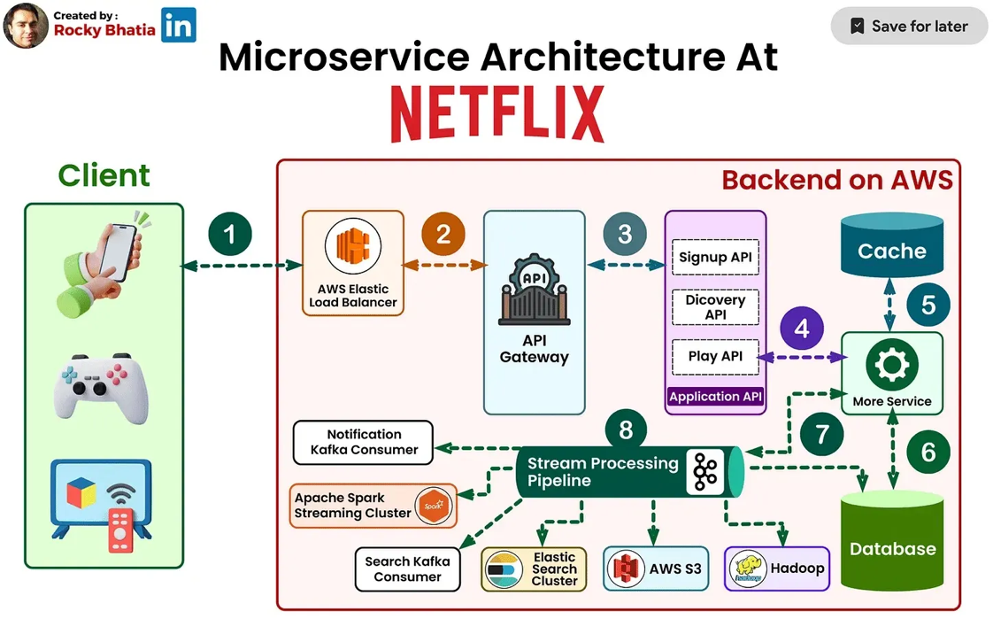
Netflix’s Cloud Infrastructure – AWS at Scale
Netflix’s cloud infrastructure is a key element of its ability to scale reliably at a global level. After a major database failure in 2008, Netflix decided to move away from its monolithic, on-premise infrastructure and transition to a fully cloud-native architecture based on Amazon Web Services. This migration was not a simple transfer of existing systems to the cloud, but a long-term effort that required redesigning the platform to support elasticity, fault tolerance, and service-oriented principles.
The cloud migration was completed in early 2016 after approximately seven years of development. As a result, Netflix transformed into a fully cloud-native platform. This shift enabled rapid provisioning of computing resources, large-scale multi-region deployments, elastic scaling during traffic spikes such as new season releases, and built-in disaster recovery capabilities. By removing the need to manage physical hardware, engineering teams were able to focus more on product development and system improvements.
Today, Netflix operates entirely on Amazon Web Services and relies on a wide range of AWS services to support its infrastructure. Elastic Compute Cloud (EC2) is used to provide scalable virtual machines for compute-intensive tasks such as video encoding and data processing.
Amazon S3 serves as a storage layer for video assets, user data, logs, and metadata.
For large-scale data storage, Netflix uses Cassandra, a distributed NoSQL database designed to handle high volumes of read and write operations. As the number of Netflix users increased, the amount of viewing history data also grew rapidly. This created challenges related to storage size, operational cost, and performance. To address this, Netflix designed its data model with two main objectives: reducing storage footprint and maintaining consistent read and write performance as user activity increased.
Netflix implemented a denormalized Cassandra architecture consisting of more than fifty clusters and over five hundred nodes, with daily backups exceeding thirty terabytes. Some clusters handle hundreds of thousands of write operations per second. Initially, viewing history was stored in a single row per user, but as row sizes increased, performance degraded. To solve this problem, Netflix separated viewing history into two categories. Recent viewing data is stored uncompressed to support frequent updates and fast processing, while older viewing records are compressed to reduce storage usage and operational cost.
Netflix also uses AWS Lambda to run serverless functions for lightweight, event-driven workloads such as log processing and real-time analytics.
Elastic Load Balancing is employed to distribute incoming traffic across frontend services and prevent overload. Netflix uses a two-level load balancing strategy, first distributing traffic across availability zones using DNS-based round-robin routing, and then balancing requests across instances within each zone.
For real-time data streaming, Netflix relies on platforms such as Kafka and Amazon Kinesis. These systems support features like personalized recommendations, experimentation, and large-scale data ingestion.
Overall, Netflix’s cloud-native architecture allows the platform to scale rapidly during peak demand and automatically recover from infrastructure failures. This approach plays a central role in maintaining high availability, performance, and reliability for a global user base.
Content Delivery at Scale – Open Connect
A major challenge for Netflix is delivering high-quality video to users without buffering or noticeable delays. To address this, Netflix developed its own content delivery network called Open Connect. This system is responsible for delivering Netflix movies and television shows to users around the world in an efficient and reliable way. While Open Connect shares similarities with traditional CDNs, it was specifically designed to meet Netflix’s large-scale streaming requirements.
Netflix launched the Open Connect initiative in 2011 in response to the rapid growth of its streaming traffic. As Netflix became a significant source of internet traffic for many Internet Service Providers, closer cooperation with ISPs became increasingly important. In addition, building a delivery system tailored specifically for Netflix allowed the company to implement a proactive caching strategy, which is more efficient than traditional demand-based CDN models. This approach significantly reduces upstream network traffic and improves delivery performance.
The main objective of Open Connect is to provide users with a consistently high-quality viewing experience by placing content as close to them as possible. By reducing the physical and network distance that video data must travel, Netflix improves playback quality while also benefiting ISPs by lowering network congestion. Over time, the Open Connect program has continued to evolve through constant monitoring and optimization to meet changing demand patterns and technological requirements.
The core components of Open Connect are specialized servers known as Open Connect Appliances. These servers store encoded video and image files and deliver them directly to client devices such as smart TVs, mobile phones, and set-top boxes using standard HTTP or HTTPS protocols. Their sole function is to deliver streaming content as efficiently and quickly as possible. Netflix is involved in designing both the hardware and software of these appliances and makes much of this work available as open source. Open Connect Appliances are deployed globally in two main ways.
First, Netflix installs them at internet exchange points in major markets, where they connect directly with ISPs through public or private peering arrangements.
Second, Netflix provides these appliances free of charge to qualifying ISPs, which then deploy them directly within their own networks. In this case, Netflix supplies the hardware, while ISPs provide power, space, and connectivity. Each deployment is carefully customized based on local network conditions, and capacity is continuously adjusted as demand changes.
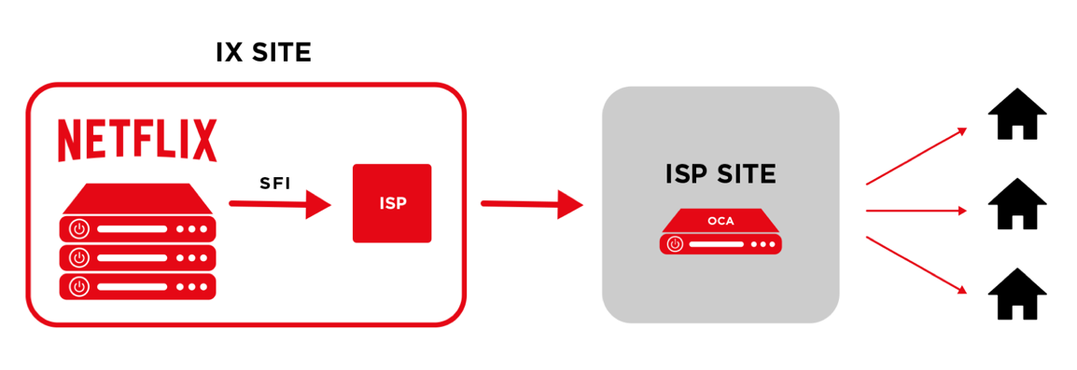
Open Connect operates in close coordination with Netflix’s cloud services hosted on AWS. The appliances do not store user data such as viewing history or account information. Instead, they periodically report health status, routing information, and file availability to control services running in AWS. When a user starts playback, Netflix’s application services verify authorization and licensing, determine the required media files, and select the most suitable Open Connect servers based on proximity, availability, and current network conditions. The selected servers then deliver the content directly to the client device.
The following diagram illustrates how the playback process works:
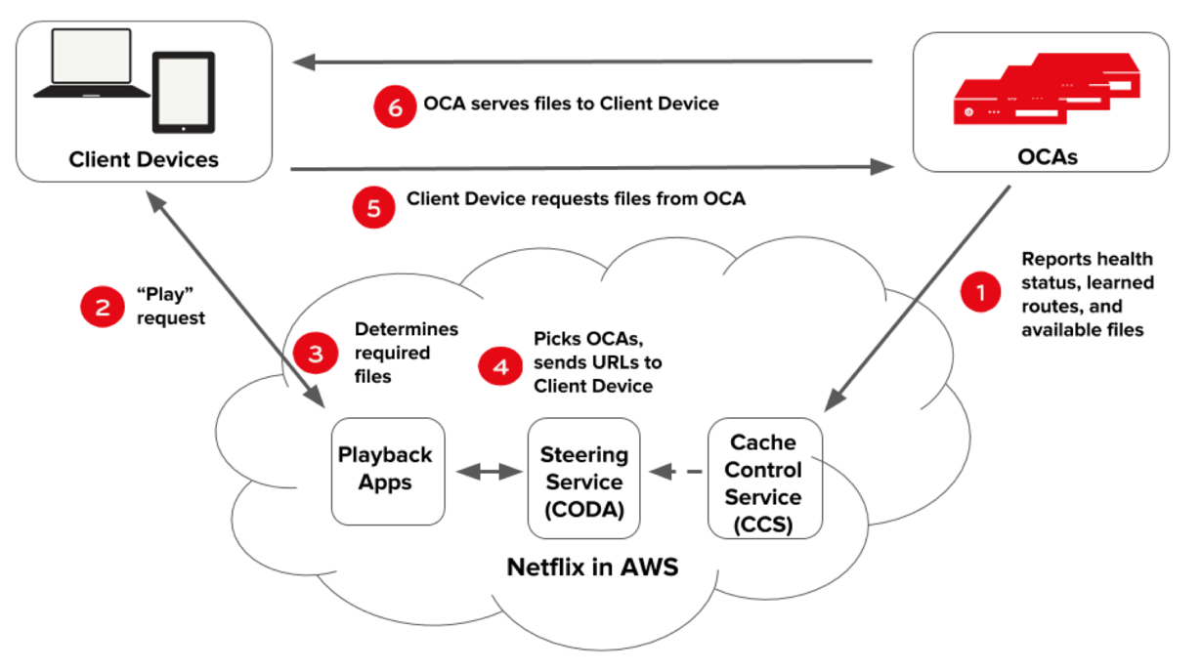
- OCA’s periodically report health, routes they have learned, and content (file) availability to the cache control services in AWS.
- A user on a client device requests playback of a title (TV show or movie) from the Netflix application in AWS.
- The playback application services in AWS check user authorization and licensing, then determine which specific files are required to handle the playback request - taking individual client characteristics and current network conditions into account.
- The steering service in AWS uses the information stored by the cache control service to pick OCAs that the requested files should be served from, generates URLs for these OCAs, and hands the URLs over to the playback application services.
- The playback application services hand over URLs of the appropriate OCAs to the client device, and the OCA begins to serve the requested files.
The Open Connect infrastructure is continuously monitored by Netflix’s operations teams to ensure reliability and performance. Most issues are resolved remotely, and hardware that no longer meets performance standards is replaced without cost to ISP partners. Netflix also takes advantage of predictable viewing patterns to distribute content updates during off-peak hours, reducing strain on core internet infrastructure. In addition, Open Connect servers can share content with one another to further optimize bandwidth usage.
Overall, Open Connect provides several key benefits. By serving content from servers located inside or near ISP networks, it reduces latency and improves streaming quality, including support for high-resolution formats such as 4K and HDR. It also lowers bandwidth usage on backbone networks and reduces operational costs associated with cloud-based content delivery. This edge-focused caching strategy plays a critical role in maintaining Netflix’s high-quality user experience at a global scale.
Netflix’s Tech Stack – From Frontend to Streaming Infrastructure
Netflix uses a wide and well-structured technology stack that supports everything from the user interface to large-scale video streaming and content delivery. This stack is designed to handle high traffic, ensure reliability, and provide a smooth viewing experience for users worldwide.
Frontend technologies: The Netflix user interface is mainly developed using React.js, which allows dynamic and responsive rendering of content across different devices. Node.js is used alongside React to support server-side rendering, improving performance and initial load times. For managing application state and handling asynchronous data flows, Netflix relies on Redux and RxJS. Data fetching is optimized through GraphQL and Falcor, which help reduce over-fetching and improve the efficiency of API responses.
Backend technologies: Most of Netflix’s backend services are implemented as microservices written in Java using the Spring Boot framework. These services handle core business logic and scale independently. Python and Go are also used for specific backend components, particularly in areas such as machine learning, data processing, and system observability. Communication between services is achieved through a combination of REST APIs and gRPC, allowing both flexibility and high-performance service-to-service interaction.
Databases and storage: Netflix relies heavily on NoSQL databases to manage large volumes of distributed data. DynamoDB and Cassandra are used for storing user preferences, viewing history, and content metadata due to their scalability and high availability. MySQL is used for transactional data, including billing and payment systems, where strong consistency is required. For storage, Amazon S3 and Elastic Block Store are used to store logs, metadata, and other supporting assets.
Event-driven architecture: To support real-time data processing and system communication, Netflix uses an event-driven architecture. Apache Kafka and AWS Kinesis are used to handle event streaming, real-time analytics, and log ingestion. These technologies allow Netflix to process large streams of data efficiently and react quickly to system events.
Streaming infrastructure: Netflix’s streaming pipeline includes several specialized technologies. FFmpeg is used for video encoding and format conversion, ensuring compatibility across devices. To evaluate and optimize video quality, Netflix developed VMAF, an AI-based quality assessment model. Streaming is delivered using adaptive bitrate protocols such as DASH and HLS, which automatically adjust video quality based on network conditions and device capabilities.
Content delivery using Open Connect
Netflix operates its own content delivery network called Open Connect. This system deploys dedicated caching servers directly within or close to ISP networks. By serving content from nearby locations, Open Connect reduces network congestion and improves streaming performance. The system also uses BGP routing to efficiently direct users to the optimal servers.
Observability and performance monitoring
To maintain system reliability at scale, Netflix uses a range of observability tools. Atlas provides real-time monitoring and metrics collection. Eureka is used for service discovery within the microservices environment. Hystrix helps manage failures by acting as a circuit breaker, while Zipkin enables distributed tracing to analyze request flows across services. Spinnaker is used to manage continuous delivery and multi-cloud deployments.
Security and digital rights management
Content protection and platform security are critical for Netflix. Digital rights management is handled through technologies such as Widevine, PlayReady, and FairPlay, which prevent unauthorized access and piracy. Token-based authentication is used to secure communication between services. In addition, Netflix applies machine learning techniques for fraud detection, helping to identify and prevent activities such as credential abuse and unauthorized account sharing.
Resilience and Fault Tolerance – Chaos Engineering
Netflix maintains high availability through the use of Chaos Engineering, an approach that focuses on improving system resilience by intentionally testing how systems behave when failures occur. Chaos Engineering is a software engineering practice that uses controlled experiments to introduce faults, unexpected conditions, or component failures into a system. The main objective is to identify weaknesses early and prevent serious outages or performance problems in real production environments.
- Engineers design experiments based on assumptions about how a system may fail under specific conditions. These experiments are automated and closely monitored to ensure that testing remains controlled and safe.
- By repeatedly detecting and fixing weaknesses, Chaos Engineering helps organizations develop systems that are more stable and capable of handling real-world failures and disruptions.
Chaos Monkey is a well-known open-source tool created by Netflix to apply Chaos Engineering principles in distributed systems. Its role is to randomly shut down virtual machine instances or services in a cloud environment in order to simulate common infrastructure failures.
- Chaos Monkey randomly selects and terminates virtual machine instances during working hours. This forces development teams to design systems that can tolerate failures without affecting service availability.
- When a system is properly designed, the loss of individual components does not lead to noticeable downtime or major service interruptions.
Purpose of Chaos Monkey: The main goal of Chaos Monkey is to strengthen the resilience and fault tolerance of distributed systems by introducing failures in a controlled and repeatable way.
- Resilience testing: Chaos Monkey continuously tests whether the system can survive unexpected component failures.
- Identifying weaknesses: Random shutdowns expose architectural or configuration issues that may otherwise go unnoticed.
- Encouraging redundancy: The tool promotes the use of redundant components, ensuring that services remain available even when individual instances fail.
- Continuous improvement: Running Chaos Monkey regularly provides ongoing feedback, allowing engineers to analyze failures and improve system design over time.
- Building confidence: Testing failure scenarios in production-like environments increases confidence that the system can handle real incidents.
- Promoting a resilience-focused culture: Regular failure testing encourages teams to treat resilience as a core system requirement rather than an afterthought.
Overall, Chaos Monkey acts as a proactive mechanism to ensure that distributed systems remain reliable and stable under unexpected conditions.
Netflix operates at a scale where unexpected failures are unavoidable, whether due to network problems, cloud infrastructure issues, or software defects. By deliberately testing these failure scenarios in advance, Netflix reduces the risk of user-visible outages and ensures that the platform continues to operate reliably under adverse conditions.
Personalisation & AI – The Brain Behind Netflix Recommendations
Netflix relies heavily on artificial intelligence and machine learning to deliver personalized recommendations to its users. The recommendation system continuously learns from user behaviour and adapts to individual preferences, playing a key role in keeping users engaged with the platform.
One of the core techniques used is collaborative filtering. This method identifies patterns among users with similar viewing habits. If users with comparable interests enjoy the same content, the system is likely to recommend similar titles across those users. Collaborative filtering can be user-based, where users are compared with each other, or item-based, where content is recommended based on similarities between titles that are often watched together. This approach helps users discover relevant content and reduces the effort needed to choose what to watch.
In addition to this, Netflix applies content-based filtering, which focuses on analysing the properties of the content itself. Each movie or series is described using detailed metadata, such as genre, themes, cast, and stylistic elements. Based on a user’s past viewing history, the system recommends content with similar characteristics. This method is especially useful for suggesting new or less popular titles that may not yet have enough user interaction data.
Netflix also uses deep learning models to capture more complex viewing patterns. These models analyse implicit signals, such as how long a user watches a title, whether they stop early, or rewatch specific scenes. This allows the system to adjust recommendations dynamically as user preferences change over time.
To further improve recommendation quality, Netflix applies reinforcement learning techniques, including contextual bandit algorithms. These methods learn from user interactions in real time, such as clicks or skipped recommendations, and refine future suggestions accordingly. All major changes to recommendation algorithms and user interfaces are validated through large-scale A/B testing before being deployed widely.
With millions of users watching content simultaneously, Netflix must track system performance in real time. Key monitoring tools include:
Atlas – Netflix’s real-time telemetry platform for tracking system health.
Eureka – Service Discovery Tool for Microservice Communication. In a cloud environment, many services—like login, recommendations, and payment—need to locate and communicate with each other to function correctly. Eureka acts like a directory or phone book for these services.
- Each service registers itself with Eureka when it starts.
- When another service needs to connect, it queries Eureka to get the service’s current address (IP and port).
It’s important, because It supports scaling—services can be added or removed dynamically, and Eureka keeps track of all instances. It enables load balancing and failover—if one instance fails, traffic can be routed to another available instance.
Netflix Eureka ensures that services can discover each other automatically, making communication in a distributed cloud system easier, more efficient, and more reliable.
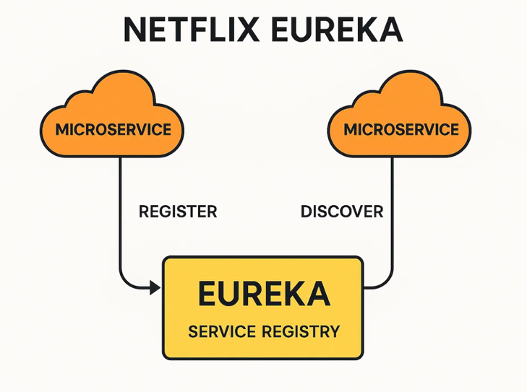
Hystrix – Circuit Breaker Library for Preventing Cascading Failures. In a distributed system, servers often depend on responses from other servers. These interdependencies can create latency, and if one server fails, it may cause a chain reaction that affects the entire system. Hystrix addresses this problem by isolating the application from failures in external services.
The library manages interactions between distributed services by adding fault tolerance and latency control. Its key functions include:
- Preventing cascading failures across interconnected services.
- Controlling latency and handling failures from dependencies, often accessed over the network or via third-party libraries.
- Failing fast and allowing the system to recover quickly.
- Providing fallback mechanisms and enabling graceful degradation when possible.
- Supporting near real-time monitoring, alerting, and operational management.
- Offering concurrency-aware request caching and automated batching through request collapsing.
By implementing Hystrix, Netflix ensures that individual service failures do not compromise the overall system, maintaining reliability and responsiveness in a complex distributed environment.
Spinnaker is an open-source, multi-cloud continuous delivery platform used to deploy software changes quickly and reliably. It is designed to support frequent and safe releases by automating the deployment process across different cloud environments. A key design goal of Spinnaker is flexibility, as it allows teams to extend and adapt deployment models to their specific needs.
Spinnaker enables teams to define delivery pipelines that describe the full release process, starting from the creation of a deployable artifact, such as a virtual machine image, JAR file, or Docker image, and ending with deployment to production. Based on practices observed across Netflix engineering teams, common delivery steps were abstracted into reusable and configurable pipeline stages. These stages can be combined to form pipelines that reflect different deployment workflows. Pipelines may be triggered manually, on a schedule, after the completion of a Jenkins job, or by other pipelines. Available stages include image baking, deployment to cloud providers, automated testing, and manual approval steps. Stages can be executed either sequentially or in parallel, depending on the deployment strategy.
From a technical perspective, Spinnaker consists of several JVM-based backend services that expose functionality through a RESTful API, accessed via a gateway service. These services are supported by a web-based user interface, which provides a centralized and consistent view of application deployments and cloud infrastructure.
Zipkin is a distributed tracing tool used to track and analyze how requests move across microservices. It helps collect timing data that is essential for identifying and troubleshooting latency issues in complex service architectures.
With Zipkin, users can search traces either by a specific trace ID or by attributes such as service name, operation, tags, and duration. The system summarizes key metrics, including the percentage of time spent in each service and whether any operations failed.
Security & Privacy
Netflix places strong emphasis on security and applies multiple measures to protect both user data and digital content:
- End-to-End Encryption: Ensures that user information and streamed content are protected from unauthorized access during transmission.
- Multi-Factor Authentication (MFA): Adds an extra layer of protection to user accounts, reducing the risk of account takeovers.
- Access Control and Role-Based Policies: Limits internal access to sensitive systems, allowing employees to access only what is necessary for their roles.
- Digital Rights Management (DRM): Uses encryption and watermarking technologies to prevent illegal copying and distribution of content.
- Bot Detection and Fraud Prevention: Detects and blocks automated attacks such as credential stuffing and misuse related to account sharing.
Netflix’s architecture demonstrates how a large-scale distributed system can remain reliable, efficient, and resilient under heavy global demand. The platform successfully supports millions of simultaneous users, delivers content with minimal delay, and recovers quickly from failures without affecting the user experience. By combining cloud infrastructure, microservices, machine learning, chaos engineering, and edge-based content delivery, Netflix has built an architecture that is widely regarded as a reference model for modern, large-scale applications.

4. CASE STUDY: YOUTUBE
YouTube, the world’s largest video-sharing platform, serves billions of hours of video content daily to over 2 billion users worldwide. This massive scale requires a sophisticated infrastructure to ensure videos load quickly and play seamlessly, regardless of location or device. At the core of this system is Google’s Content Delivery Network (CDN), specifically the Media CDN, built on the same technology that powers YouTube. Key components like Google BigTable for metadata management and a robust video processing pipeline enable YouTube to handle the immense volume of uploads and streams. Unlike Netflix, which distributes pre-encoded content largely through a controlled catalogue, YouTube must support continuous ingestion of user-generated videos, dynamic transcoding pipelines, real-time metadata processing, frequent writes to storage systems, and extremely high read traffic from millions of concurrent viewers. The system must scale not only content delivery but also ingestion, indexing, search, analytics, recommendation, and real-time quality adaptation. As academic studies on YouTube’s architecture have observed, Google’s platform is notable not only for its ability to serve enormous traffic volumes but for its highly optimized internal cloud infrastructure, which includes custom data centers, distributed processing frameworks, and global network control.
Reasons YouTube Uses a CDN
- Reduce buffering and decrease loading times for videos.
- Deliver content to users from nearby edge servers around the world.
- Support billions of concurrent video streams.
- Improve system reliability and availability.
- Provide a consistent viewing experience for users globally.
By storing popular videos on edge servers, YouTube can deliver content more quickly than if every request had to come from a central data center.
Google’s Global Infrastructure:
Google operates one of the largest private network infrastructures in the world, which supports services such as YouTube, Google Search, and Gmail. This global infrastructure is designed to deliver content reliably and with low latency at a very large scale. Its main components include the following.
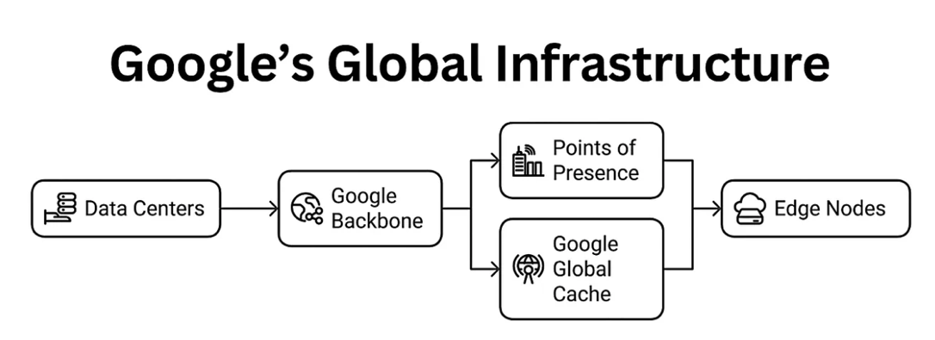
Google runs data centers distributed across more than 30 regions and around 90 zones worldwide. These facilities host servers responsible for video processing, data storage, and content distribution.
At the core of this infrastructure is Google’s private backbone network. It spans millions of kilometers of fiber-optic cables, including several submarine cables such as Curie, which connects the United States and Chile, and Equiano, linking Europe and Africa. This backbone connects hundreds of points of presence and is designed for very high speed and reliability, forming what Google describes as a planet-scale network.
Points of Presence (PoPs) are located in over 200 cities across more than 90 countries. These PoPs connect Google’s private network to local internet service providers, helping to reduce latency by keeping traffic closer to end users.
To further improve content delivery, Google uses Google Global Cache (GGC). These are caching servers installed directly inside ISP networks. Popular YouTube videos and other content are pre-cached on these servers so that they can be delivered locally. In many cases, between 70 and 90 percent of cacheable traffic can be served from GGC, which reduces congestion on external network links and improves reliability. The system is transparent to users, includes built-in redundancy, and is managed remotely by Google after initial setup.
In addition, Google deploys edge nodes that handle tasks such as request routing, load balancing, and caching decisions in real time. These nodes sit at the edge of the network and act as a bridge between local networks and Google’s global infrastructure, also contributing to performance and security.
Together, this infrastructure allows YouTube to deliver billions of video streams every day with minimal delay. With an egress capacity exceeding 100 terabits per second, Google’s Media CDN is able to support massive traffic volumes while maintaining a consistent viewing experience for users worldwide.
The Role of Google BigTable in YouTube’s Infrastructure
Google Bigtable plays an important role in YouTube’s infrastructure by providing a highly scalable and low-latency storage system for large amounts of metadata. It is a distributed NoSQL database built to handle very high read and write throughput, managing petabytes of data across thousands of machines. Unlike traditional relational databases, Bigtable stores data as a sparse, multi-dimensional map indexed by row key, column key, and timestamp. This design makes it well suited for workloads such as video metadata, user interactions, and other large-scale structured data used by YouTube.
Bigtable is especially suitable for applications that require high throughput for key-value data, where individual values are relatively small. It is commonly used as a storage backend for batch processing with MapReduce, stream analytics, and machine learning workloads, all of which are important parts of YouTube’s data processing pipeline.
The Bigtable storage model is based on large tables that act as sorted key-value maps. Each table consists of rows, which usually represent a single entity, and columns that store values for that entity. Rows are identified by a unique row key, while related columns are grouped into column families. Each column is defined by its family and a column qualifier. At the intersection of a row and a column, Bigtable can store multiple versions of a value (cells), each identified by a timestamp. This makes it possible to keep a history of changes over time. Because tables are sparse, columns that are not used for a given row do not consume storage space, which improves efficiency at scale.
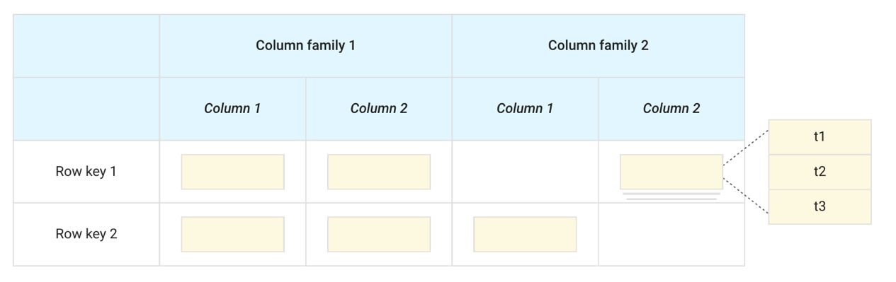
A few things to notice in this illustration:
- Columns can be unused in a row.
- Each cell in a given row and column has a unique timestamp (t).
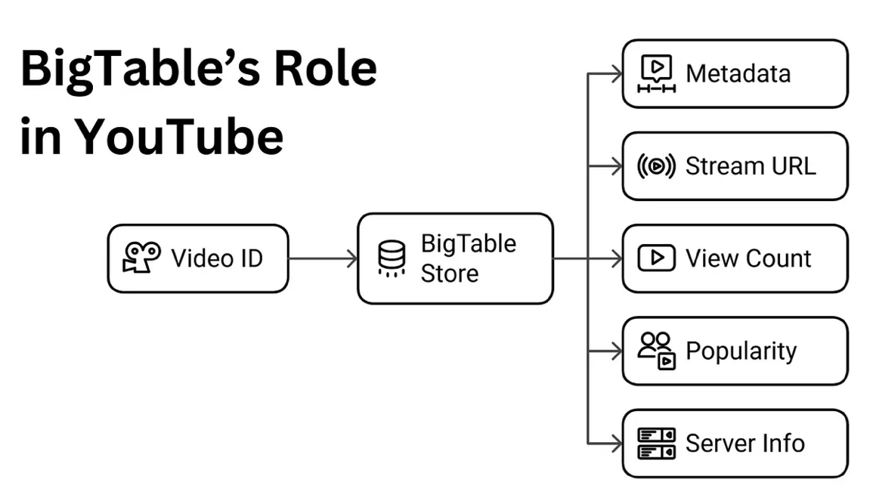
BigTable plays a central role in YouTube’s backend by managing the large volume of metadata associated with videos, such as video identifiers, titles, descriptions, tags, and references to streaming locations. This allows the platform to retrieve information quickly and reliably at a global scale. Its main responsibilities can be summarized as follows:
- Metadata storage: Video metadata is stored and indexed using the video ID, enabling fast and efficient lookups.
- Content retrieval: The stored metadata helps locate the actual video files and identify available cached copies within the delivery infrastructure.
- Server selection: BigTable supports CDN and load-balancing logic by providing information about server availability and geographic proximity.
- Dynamic updates: It continuously records changing data, such as view counts and popularity signals, which influence caching and delivery decisions.
Thanks to its very low read latency, typically in the order of milliseconds, and its ability to handle millions of operations per second, BigTable enables YouTube to serve metadata requests from millions of concurrent users without performance degradation.
YouTube’s Video Processing: When a video is uploaded to YouTube, it goes through a structured processing pipeline that prepares it for storage and delivery to viewers. This process is often referred to as the video lifecycle and includes five main stages: upload, transcoding, storage, caching, and streaming.
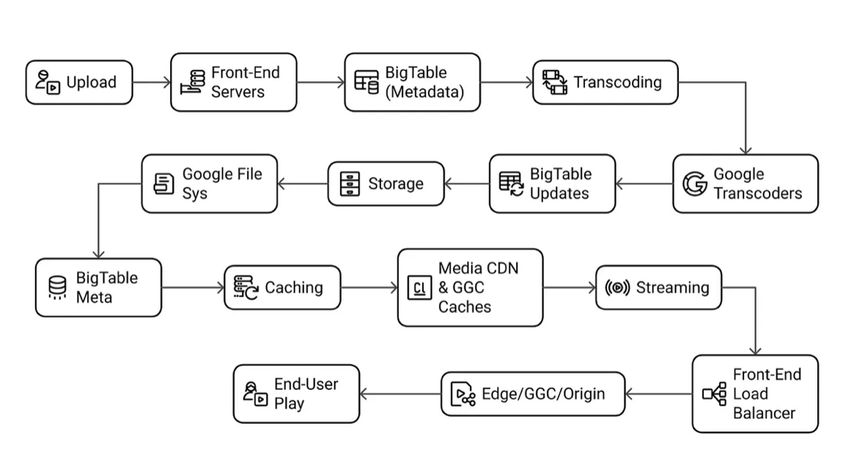
Step-By-Step Video Lifecycle
Upload: A user uploads a video through YouTube’s web or mobile application. The video is transferred over a secure HTTPS connection to a Google data center, usually the one closest to the user.
Uploads are first handled by YouTube’s front-end servers, which authenticate the user and check that the file format is supported, such as MP4 or AVI. At the same time, metadata like the video title, description, and tags is submitted and stored in BigTable.
Because more than 500 hours of video are uploaded every minute, YouTube relies on load balancing to spread incoming uploads across multiple data centers and avoid overloading individual servers.
Transcoding: After the upload is complete, the video is processed by Google’s transcoding infrastructure. The original file is converted into multiple resolutions and formats, such as 240p, 360p, 720p, 1080p, and 4K, so it can be played on different devices and under varying network conditions.
Google uses specialized hardware, including the Video (trans)Coding Unit introduced in 2021, which significantly improves efficiency for modern codecs like VP9 and AV1. This reduces processing time while maintaining high video quality at lower bitrates. Information about the available encodings is stored in BigTable so the video player can later choose the most suitable version.
Storage: Once transcoding is finished, the video files are stored in the Google File System, a distributed file system designed to handle very large amounts of data. Metadata and references to the physical locations of the video files are stored separately in BigTable.
The file system ensures durability by replicating data across multiple data centers. At the same time, BigTable’s flexible and horizontally scalable design allows YouTube to store metadata for billions of videos, including details such as video length, uploader information, and view counts.
Caching: Videos that become popular are cached closer to users on Media CDN edge servers and Google Global Cache nodes, which are deployed in thousands of locations worldwide. Videos with lower demand remain stored only in central data centers.
BigTable metadata is used to decide which videos should be cached, based on indicators such as view counts and trending status. Predictive caching helps place popular content in advance at edge locations, reducing startup delay. For example, a video that goes viral in Singapore can be cached inside a local ISP network, allowing users to start playback almost immediately.
Streaming: When a user plays a video, YouTube’s front-end servers query BigTable to retrieve the required metadata and determine the best source for streaming, whether that is an edge server, a GGC node, or a central data center. The video is then delivered through the CDN to the user’s device.
Server selection is guided by load-balancing decisions that consider latency, current server load, and content availability. The video player uses adaptive streaming protocols such as DASH or HLS to adjust quality in real time. In practice, GGC nodes deliver around 70–90% of cacheable traffic locally, which reduces network hops and improves overall playback performance.
Adaptive Bitrate Streaming (ABR) is a method used to change video quality in real time according to the user’s network conditions. Its main goal is to reduce buffering and provide smooth video playback, even when the connection quality changes.
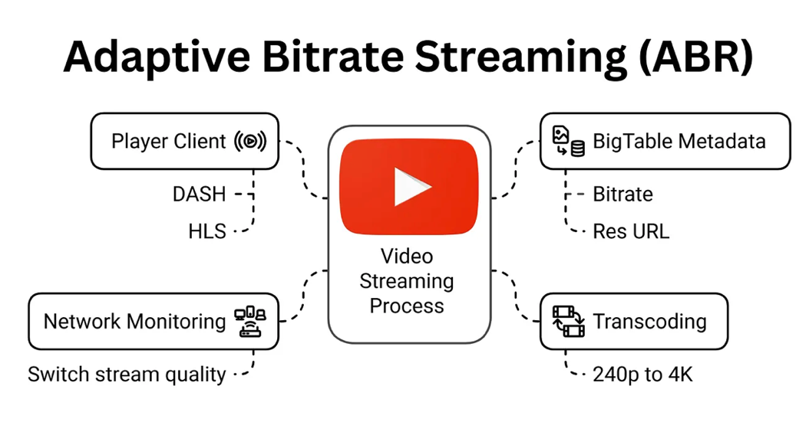
How ABR works
1. Encoding: During the transcoding phase, each video is converted into several versions with different resolutions and bitrates. For example, a single video may be available in 240p with a low bitrate, 720p in high definition, and 4K with a much higher bitrate. Information about these versions, such as their bitrates and access URLs, is stored in BigTable.
2. Dynamic adjustment: The YouTube video player uses streaming protocols such as Dynamic Adaptive Streaming over HTTP (DASH) or HTTP Live Streaming (HLS) to continuously monitor network speed and device performance. If the connection becomes slower, the player automatically switches to a lower-quality stream, for example from 1080p to 360p, without stopping the video.
3. Implementation: When a user starts watching a video, BigTable provides metadata about all available stream versions. Based on this information, the player selects the highest quality that the current network can support and downloads video segments from the CDN. If network conditions change, the player can switch to a different stream smoothly using updated metadata.
4. Benefits: ABR helps avoid buffering on unstable connections and uses bandwidth more efficiently. For instance, a user on a slow mobile network may receive a 240p stream, while a user with a fast fiber connection can watch the same video in 4K.
Technical details
Protocols: DASH and HLS divide videos into small segments, usually lasting between 2 and 10 seconds. Each segment is available in multiple quality levels, allowing the player to switch quality between segments when needed.
BigTable integration: BigTable provides low-latency access to metadata about available segments and bitrates, which allows the player to react quickly when switching streams.
CDN support: Media CDN caches these video segments at edge locations. If a required segment is not available locally, it is fetched from the origin servers, with the process guided by metadata stored in BigTable.
Network Optimization Technologies.
QUIC Protocol: YouTube uses Google’s QUIC (Quick UDP Internet Connections) protocol to improve video streaming performance. Compared to traditional TCP, QUIC provides several important improvements:
- Faster connection setup
- More efficient congestion control
- Better performance on unstable or lossy networks
- Support for multiple streams without head-of-line blocking
This protocol is especially useful for mobile users who often change networks, such as switching from Wi-Fi to a cellular connection.
YouTube relies on Google’s private fiber optic network, which spans more than 1.5 million miles of cable worldwide. This private infrastructure offers:
- Higher bandwidth capacity
- Lower network latency
- Greater reliability compared to public internet paths
The network includes many strategically placed points of presence (PoPs), allowing content to be delivered from locations close to users, which improves speed and reliability.
Storage Infrastructure
1. Distributed File System: YouTube stores its large video library, consisting of billions of terabytes, using Google’s distributed file system built on consumer- and business-grade hard drives. This design provides:
- Very high scalability
- Cost-efficient storage
- Built-in data redundancy
Instead of using expensive enterprise storage systems, Google distributes data across thousands of standard servers, with automatic replication to handle failures.
2. Modular Data Centers: Most YouTube data is stored in Google’s modular data centers. These are portable, self-contained units that can be deployed quickly where more capacity is required. They allow Google to:
- Deploy infrastructure faster in new regions
- Improve power and cooling efficiency
- Scale storage gradually as demand increases
YouTube’s CDN Operations: YouTube’s content delivery network, based on Google’s Media CDN, improves video delivery through several mechanisms.
1. Content Distribution
- Popular videos: Frequently watched videos are cached on edge servers and Google Global Cache (GGC) nodes. BigTable metadata helps identify trending content, so widely viewed videos, such as popular music clips, are cached globally.
- Less popular videos: These are served directly from YouTube’s data centers, with BigTable providing information about file locations to reduce access time.
2. Load Balancing and Server Selection: Server selection uses metadata stored in BigTable and considers:
- Performance metrics: Network latency, number of hops, and server availability
- Content popularity: Higher-demand videos are prioritized for caching
- Load distribution: Traffic is spread across servers to avoid overload, even if this means serving content from a more distant location. Studies have shown that users in countries such as Finland may sometimes receive content from servers in Switzerland or the United States.
3. Content Propagation: Newly uploaded videos are first stored on main servers, for example in locations such as California or Sweden. BigTable updates metadata to track where content is available. As demand increases, popular videos are progressively cached on edge servers closer to users.
Technical Details of Media CDN: The Media CDN architecture consists of several key components:
- Router: Directs user requests to appropriate cache servers based on IP address, protocol, and security rules.
- Cache: Stores video content locally to reduce requests to origin servers. Cache behavior is optimized using BigTable metadata.
- Cache filler: Retrieves content from origin servers when it is not already cached and stores it for future requests, following metadata provided by BigTable.
Additional characteristics include configurable caching policies, such as cache keys and time-to-live (TTL) values, and a total egress capacity exceeding 100 terabits per second, which allows YouTube to operate at a global scale.
Advanced Techniques
1. Caching and Latency Reduction: Edge caching, supported by GGC nodes and local internet service providers, plays a key role in reducing latency. Frequently watched videos are copied to edge points of presence based on user access patterns, which reduces the need to retrieve content from distant core data centers. Replication across regional data centers improves redundancy, while Google’s Media CDN applies cache eviction policies that prioritize high-demand content. For example, a viral video can be cached in most GGC nodes worldwide within a few hours, allowing many users to experience latency below 100 milliseconds.
2. Fault Tolerance and Chaos Testing: YouTube achieves very high availability, even during large-scale events such as live concerts or major sports broadcasts, through a fault-tolerant system design. Multiple network paths between data centers and edge nodes allow traffic to be rerouted if a server or connection fails. Google also uses chaos testing tools, such as Chaos Monkey, to intentionally introduce failures and verify system resilience. For instance, if a GGC node in London becomes unavailable, traffic can be automatically redirected to a nearby node in Frankfurt without affecting users. In addition, Spanner’s global replication ensures that critical metadata remains accessible.
3. Security and DDoS Protection: YouTube protects its platform using strong security measures, including encrypted data transmission over HTTPS, encrypted storage, and role-based access control. Google Cloud Armor works with the CDN to defend against DDoS attacks by monitoring traffic patterns and blocking malicious requests. During a suspected attack, Cloud Armor can limit traffic from suspicious IP addresses or redirect traffic to filtering systems. Combined with rate limiting and redundant network paths, these measures help maintain service availability.
In Conclusion, YouTube’s capacity to deliver billions of videos each day is supported by Google’s advanced CDN infrastructure. This system combines client-to-backend architecture, edge caching through GGC, adaptive streaming using DASH and HLS, and efficient load balancing with anycast and Maglev. Fault-tolerant design, optimized upload workflows, and strong security mechanisms such as Cloud Armor ensure reliable and secure service. From an engineering perspective, YouTube’s architecture demonstrates effective approaches to building scalable, low-latency, and resilient global content delivery systems.

5. COMPARATIVE ANALYSIS
The analysis of Netflix and YouTube shows that both platforms are built as large-scale distributed systems, but their architectures have evolved in different ways due to differences in content type, ownership of infrastructure, and operational goals. Despite these differences, both systems rely on the same fundamental principles of scalable distributed system design.
Aspect | Netflix | YouTube
Core architectural model | Cloud-native microservices architecture deployed on AWS. Each service (authentication, recommendations, playback) operates independently and scales horizontally. | Distributed service-oriented architecture built on Google’s internal infrastructure (Google Cloud and custom systems). Uses scalable decomposition for upload, search, streaming, caching, and metadata services.
Hosting and infrastructure | Hosted entirely on public cloud (Amazon Web Services), relying on EC2, S3, DynamoDB, etc., for compute, storage, and data services. | Hosted on Google’s private, global infrastructure. Core services and data stores run on Google’s internal platforms rather than third-party clouds.
Service communication and orchestration | Services communicate via APIs (REST/gRPC) with centralized service discovery and client-side load balancing (multiple OSS libs). | Services communicate through internal RPC, distributed pipelines, and Google’s internal infrastructure protocols. Individual subsystems (like search, ingestion) scale independently.
Scaling strategy | Horizontal auto-scaling of stateless microservices using AWS auto-scaling and regional replication. | Horizontal scaling via Borg (Google’s container manager) and global infrastructure, with dynamic allocation of resources across thousands of machines.
Content delivery and caching | Uses proprietary CDN (“Open Connect”) placed at ISP edge locations for efficient content delivery; caches popular content close to users. | Uses Google’s global CDN (Google Global Cache) with multi-layer caching: edge, regional, and origin caches to serve video content efficiently.
Video ingestion and processing | Videos are pre-encoded and stored in cloud; Netflix creates multiple bitrate versions ahead of time. | Continuous upload pipeline: users upload videos which are immediately transcoded into multiple formats and stored; system supports very high ingestion rates.
Fault tolerance and resilience | Designed for failure with fault isolation per microservice; uses chaos engineering tools (e.g., Chaos Monkey) to exercise resilience. | High redundancy via data replication and global load balancing. YouTube’s distributed system redirects traffic and replicates services to sustain failures.
Data consistency approach | Eventual consistency for most distributed services, with stronger local consistency where required (in caches and data stores). | Eventual consistency for global caches and metadata; strong consistency enforced selectively where needed (e.g., user account metadata).
Analytics and machine learning | Extensive use of ML for personalization, content recommendation, and quality-of-experience optimization. | Uses large-scale ML for ranking, search quality, recommendation, content moderation, and ad targeting integrated into core services.
Overall, the comparison shows that Netflix and YouTube follow different architectural paths but converge on the same core ideas of scalable distributed systems. Horizontal scaling, automation, caching, fault tolerance, and global distribution are essential for both platforms. The differences in implementation reflect the specific requirements of their content models and organizational structures, but the underlying distributed system principles remain largely the same.

6. CHALLENGES
Despite the high level of maturity reached by large streaming platforms such as Netflix and YouTube, scaling distributed streaming systems remains a complex and evolving problem. As user demand continues to grow and technologies change, several technical challenges persist, while new research directions are emerging to address them. One of the main challenges is handling sudden and unpredictable traffic spikes. Streaming platforms often experience extreme increases in load during popular content releases, live events, or viral trends. Although autoscaling and load balancing help manage these situations, reacting fast enough without overprovisioning resources remains difficult. Scaling too slowly can lead to buffering and service degradation, while scaling too aggressively increases operational costs. Finding better predictive scaling models that balance performance and cost is still an open problem.
Another important challenge is data consistency across highly distributed systems. Both Netflix and YouTube rely on replication and geographically distributed data stores to achieve low latency and fault tolerance. However, maintaining strong consistency across regions is expensive and often impractical at large scale. As a result, systems usually accept eventual consistency, which can lead to temporary inconsistencies in metadata, recommendations, or view counts. Future research is needed to improve consistency models that provide stronger guarantees without sacrificing performance.
Operational complexity is also a major issue. Modern streaming platforms consist of thousands of microservices, multiple caching layers, global CDNs, and complex monitoring systems. While this modularity improves scalability and resilience, it also makes debugging, testing, and system understanding more difficult. Observability tools such as distributed tracing and real-time telemetry help, but managing failures in such large systems still requires significant engineering effort. Research into automated debugging, self-healing systems, and AI-assisted operations could reduce this complexity.
Cost efficiency is another growing concern. Delivering high-quality video content at global scale requires massive bandwidth, storage, and compute resources. Even with advanced CDNs and caching strategies, streaming platforms must carefully balance video quality, latency, and operational cost. Higher resolutions such as 4K and HDR significantly increase bandwidth usage. Future work may focus on more efficient video codecs, smarter caching strategies, and adaptive delivery mechanisms that reduce cost while maintaining user experience.
Energy consumption and sustainability have also become important challenges. Large data centers, global networks, and continuous video streaming consume significant amounts of energy. As streaming traffic continues to grow, its environmental impact becomes more relevant. Research directions include energy-aware scheduling, more efficient hardware, and optimizing delivery paths to reduce unnecessary data transfer. Sustainability is likely to become a key design consideration for future large-scale systems.

7. CONCLUSION
This report examined how large streaming platforms scale their systems by analyzing the architectures of Netflix and YouTube. Both platforms operate at a global scale and must deliver content to millions of users simultaneously while maintaining low latency, high availability, and a consistent quality of service. Through these case studies, the report showed how theoretical concepts from distributed systems are applied in real-world environments.
Netflix and YouTube follow different architectural paths, mainly due to their history and content models, but they rely on similar core principles. Both systems use horizontal scaling, extensive automation, global load balancing, and layered caching through content delivery networks. These mechanisms allow them to handle unpredictable traffic patterns and regional demand while keeping performance stable. Fault tolerance is treated as a fundamental requirement, not an exception, and both platforms are designed to continue operating even when individual components fail.
The analysis highlighted how Netflix focuses on a cloud-native microservices architecture built on AWS, combined with its private Open Connect CDN to optimize content delivery close to users. In contrast, YouTube benefits from Google’s internal global infrastructure, using large-scale distributed storage, custom networking, and a highly optimized video processing pipeline to support massive volumes of user-generated content. Despite these differences, both platforms demonstrate that scalability depends not only on infrastructure, but also on careful system design, monitoring, and operational practices.
Another important insight from this study is that scalability is not a single technical solution but a continuous process. As user demand grows, new challenges appear related to cost, complexity, data consistency, and sustainability. Technologies such as edge computing, serverless execution, and AI-driven automation are becoming increasingly important to address these challenges and improve system efficiency.
Overall, this report shows that modern streaming platforms are strong examples of advanced distributed systems in practice. Netflix and YouTube illustrate how combining cloud computing, distributed storage, adaptive streaming, and automated operations makes it possible to serve content reliably at planetary scale. The lessons learned from these systems are not limited to media platforms and can be applied to many other large-scale applications that require high performance, resilience, and scalability.

8. REFERENCES
1. Open Connect – Netflix’s Global Content Delivery Network. Netflix Tech Blog.
2. Bhatia, R. (2023). Inside Netflix’s Architecture. Medium/Technical Engineering Blog.
3. How YouTube Streams Billions of Videos Every Day – Medium Engineering Blog.
4. Netflix Architecture Case Study - Nayab Tariq (2025).
5. System Design Netflix | A Complete Architecture – GeeksforGeeks.org (2025)
6. Netflix Engineering. (Hystrix,Spinnaker,Zuul,Eureka) Netflix Tech Blogs.
7. What is Load Balancer & How Load Balancing works? - GeeksforGeeks.org (2025)
8. What is Auto Scaling? - GeeksforGeeks.org (2025)
9. What Is a CDN? – Beatrice Rascuite (2022)
10. Google BigTable Documentation – Google Cloud
11. Bhatia, R. (2025). Youtube Architecture. Youtube Tech Blog.

